Assignment 1

* Create a CloudWatch alarms for an instance.
* You can create a CloudWatch alarm that monitors CloudWatch metrics for one of your instances. CloudWatch will automatically send you a notification when the metric reaches a threshold you specify. You can create a CloudWatch alarm using the Amazon EC2 console or using the more advanced options provided by the CloudWatch console.
* To create an alarm to stop an idle instance and terminate an idle instance (Amazon EC2 console)

Steps to Create Cloud Watch Alarm:

1. Create an SNS and configure with Gmail.
2. First Create a Topic name as CPU-Alarm-Topic and Click on Next.

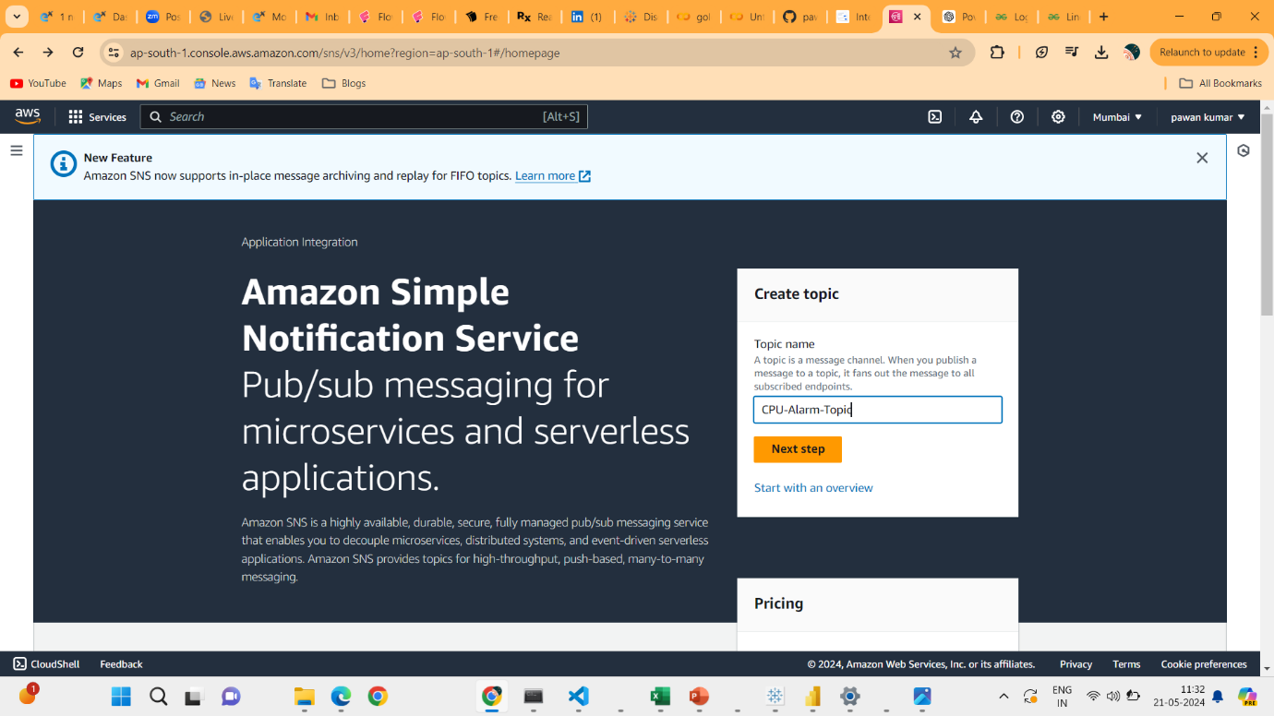

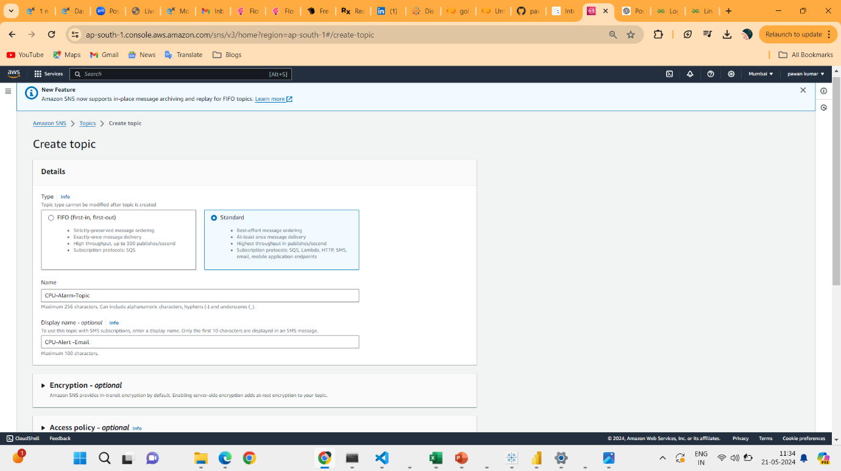

1. Give name CPU-Alarm-Topic display name as CPU-Alert -Email.
2. Click on Next Then Click On Create Subscribtion.
3. Select Protocal as Email
4. At End Point Type gmail address which we want to notification alert. I will give my personal Email Id [pavanmudamala123@gmail.com](mailto:pavanmudamala123@gmail.com) and then Click Create Subscribtion.

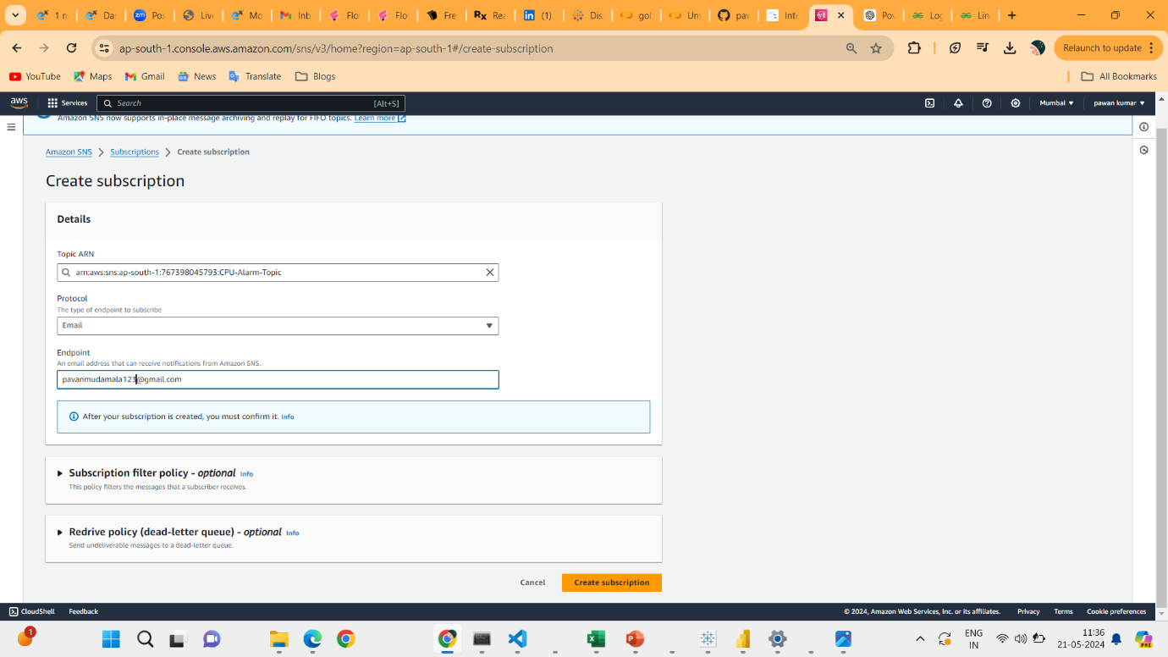

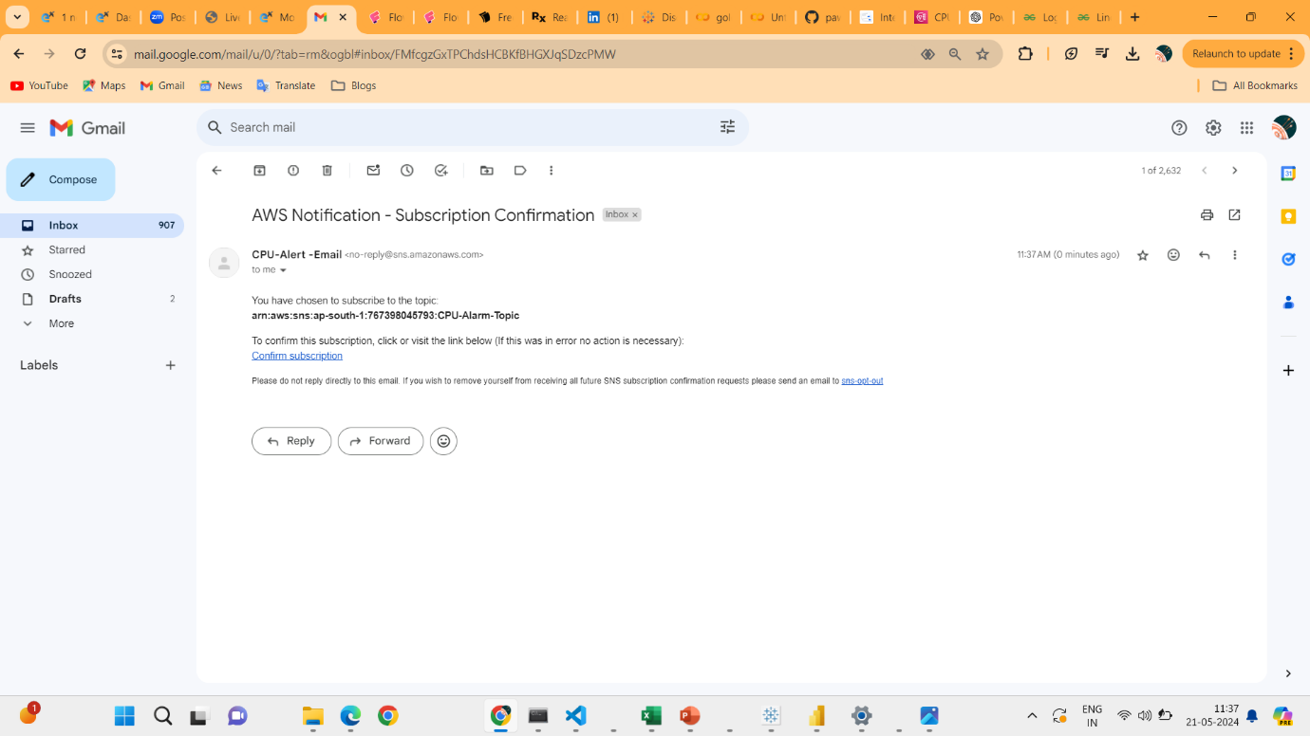

1. Check the gmail which we given in SNS. Click on Confirm Subscription.
2. Beleow image is confirm staus.

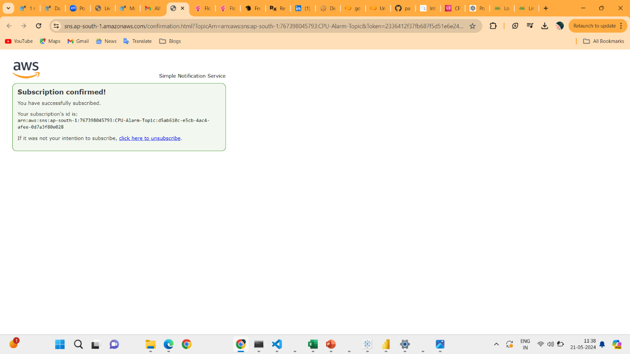

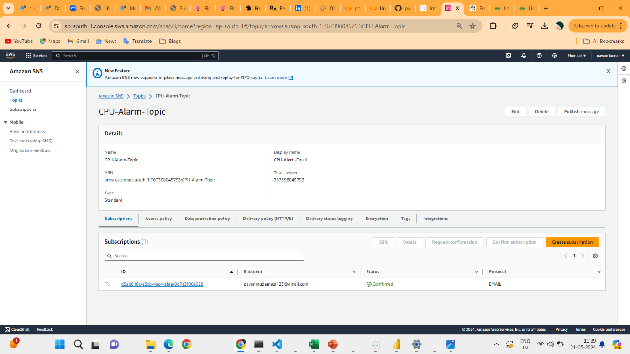

1. Go to Instance Launch an Linux server Instance.
2. Below image will show the status of Instance.

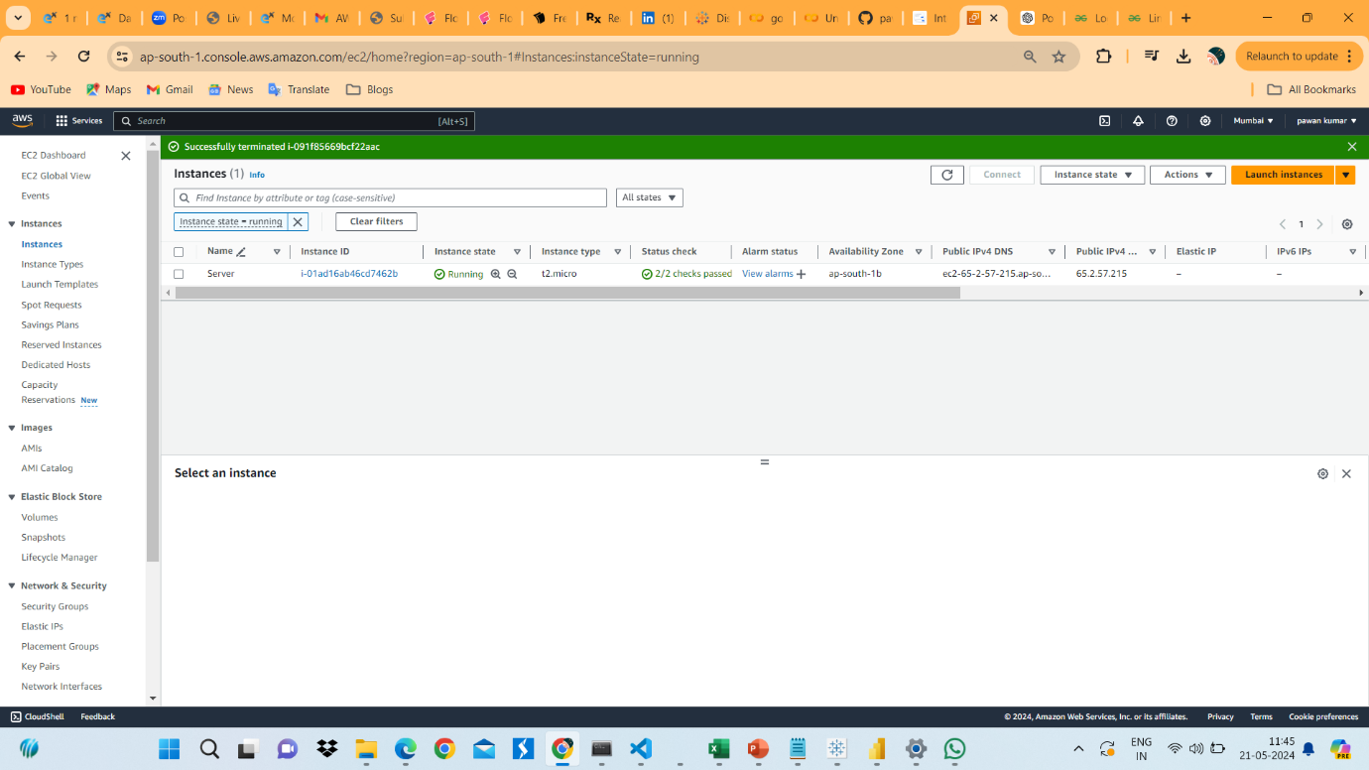

11.Go to Alarm Section and click on Create alarm.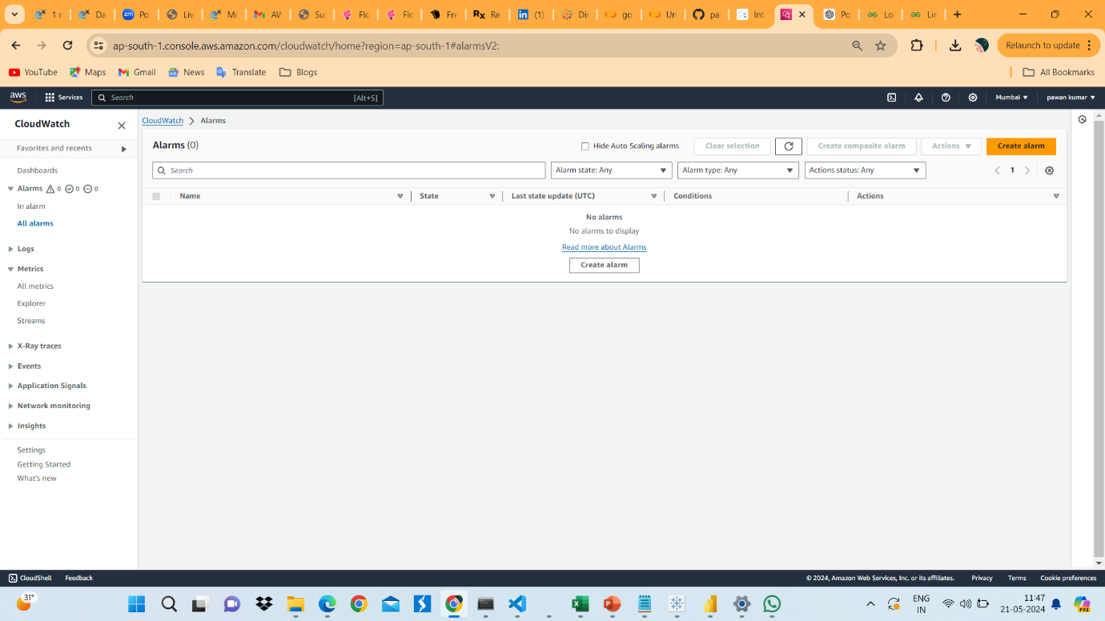

12. Then this page will appear. Select a metrics.

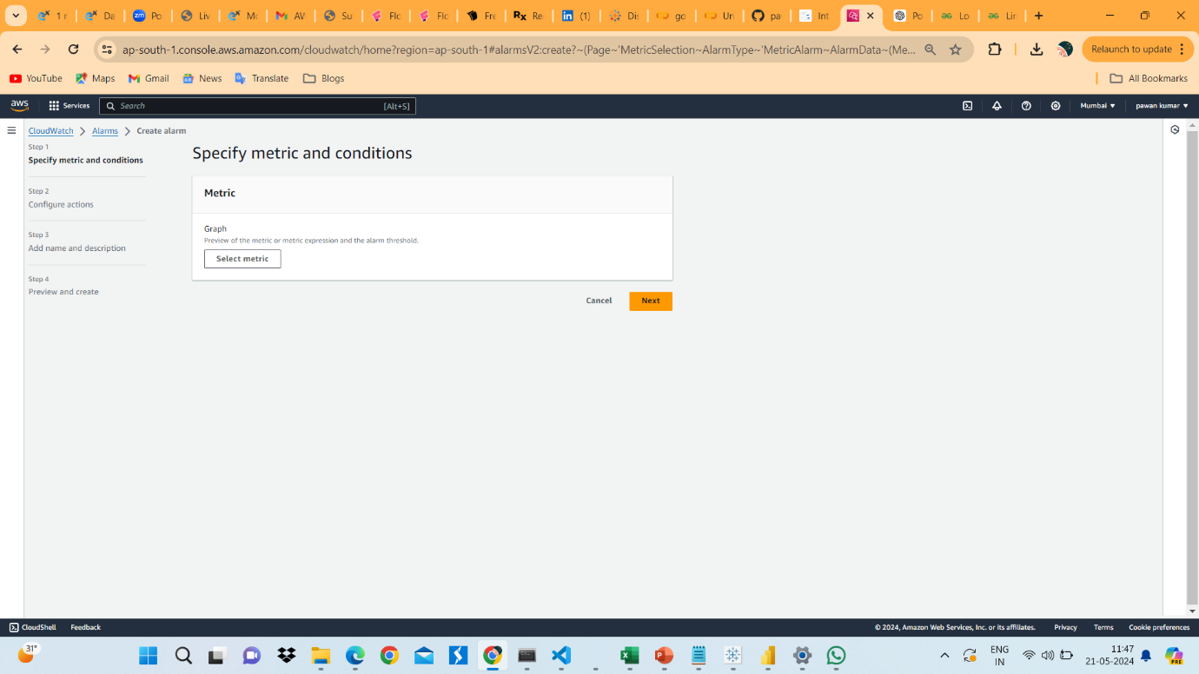

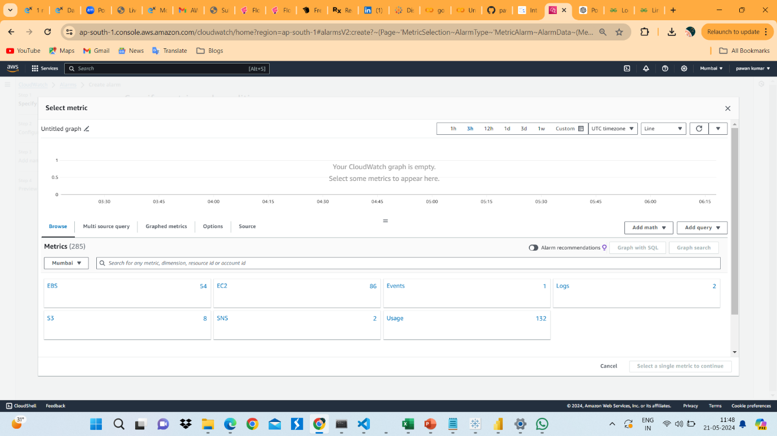

13.Select EC2 as metrics in Browse tab.

14. Select Ec2 Instance which we want t configure.

15. Select CPU Utilization. Then click on Select metrics.

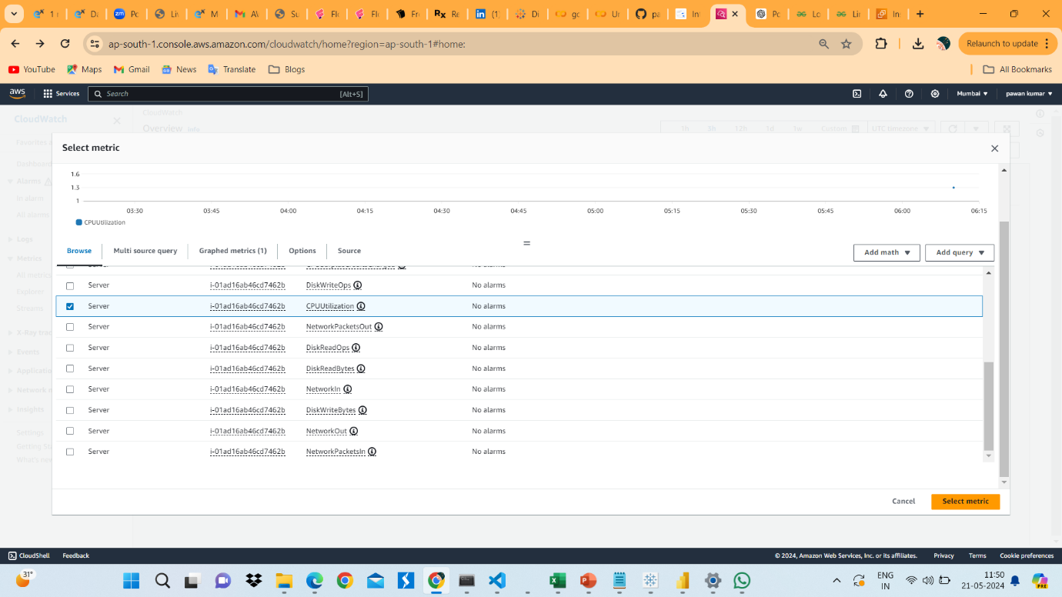

16.Specify the metric Conditions Statis field as Average and Prioad is One Minute.These means for avery minute cloud warch will Monitor the server. 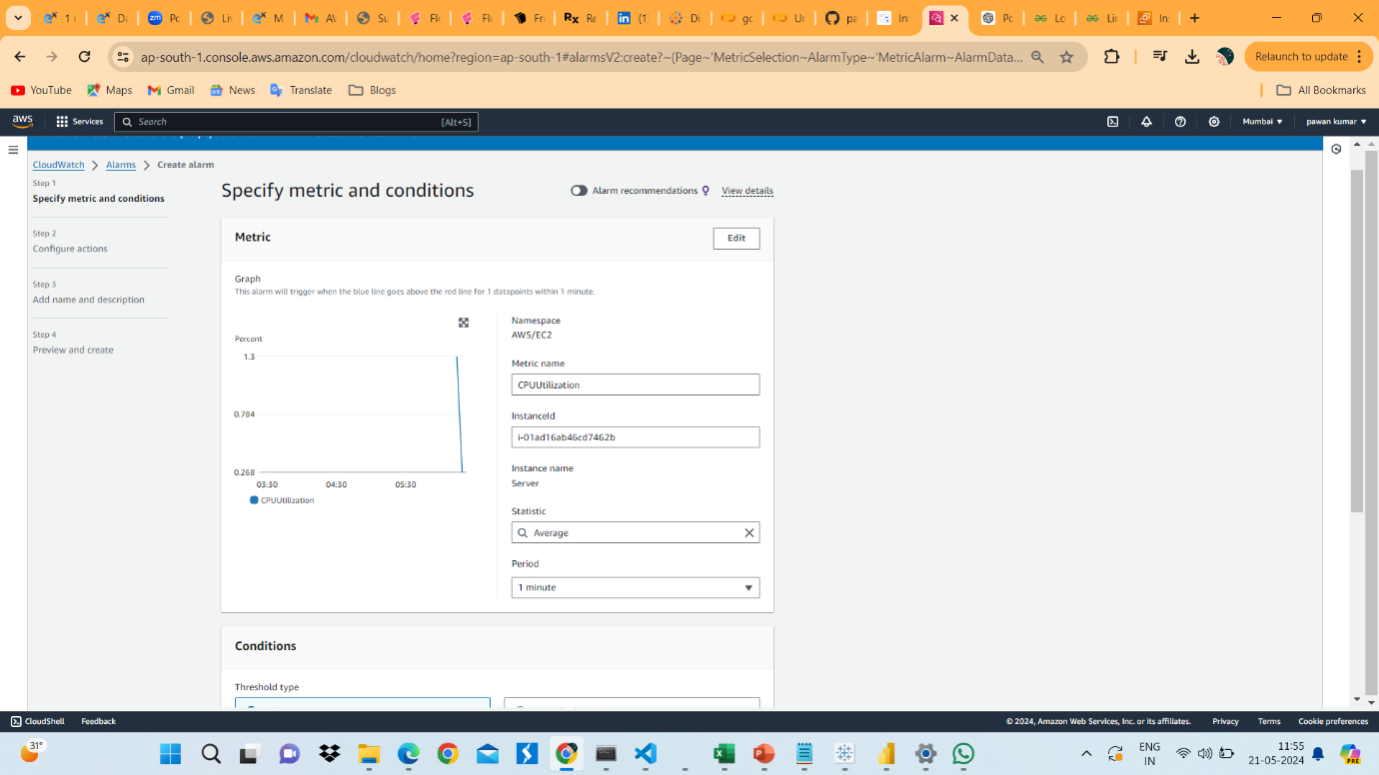

17. Give the condition of CPU Utilization. I will Give 5% of CPU Utilization for testing Purpose. But in Real Time it will be above 75%. Click on Next.

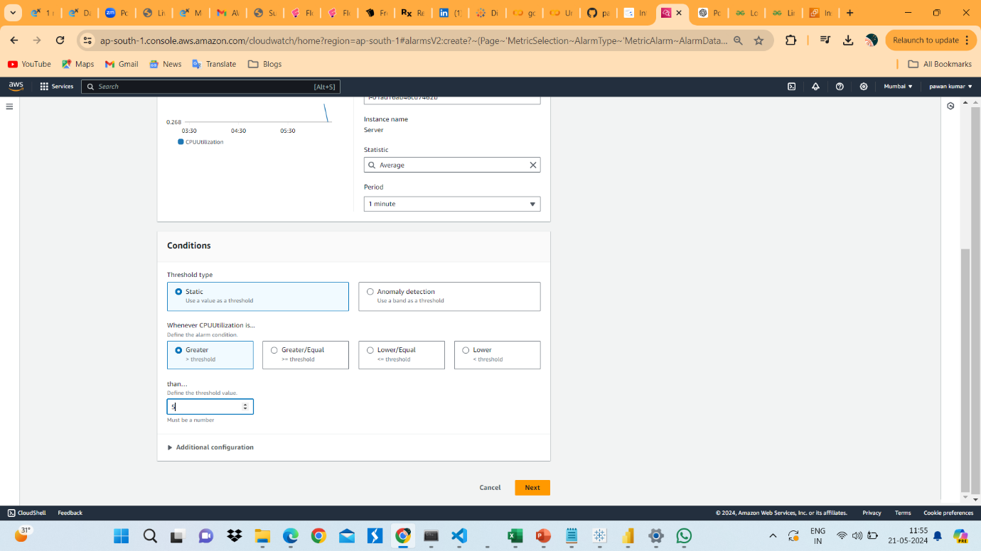

18. In Configure Actions Select In Alarm in Notification. And Send Notification Bar select SNS which we created in Before.

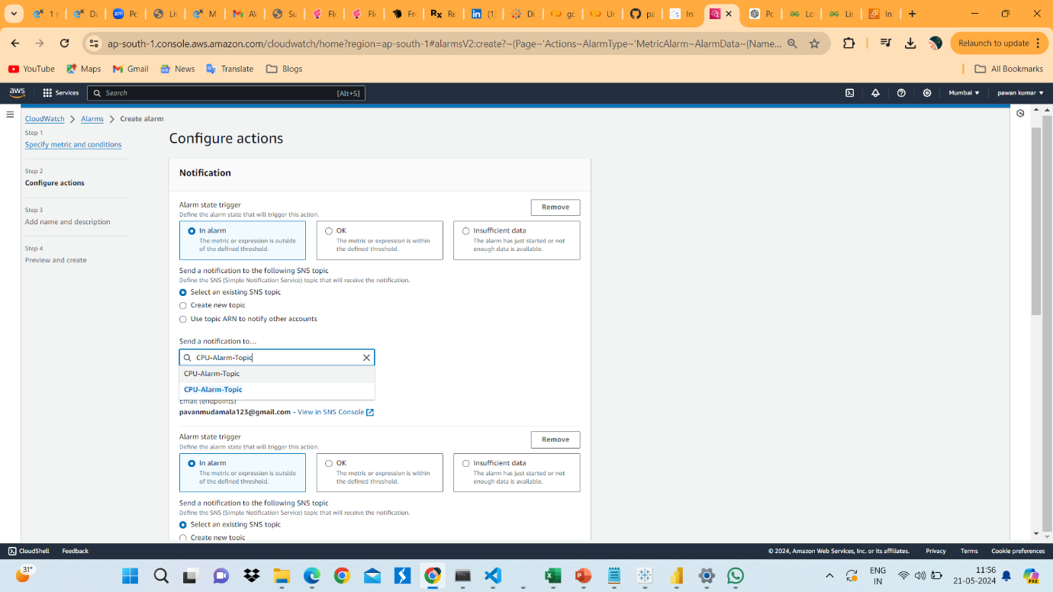

19. In EC2 Action Select Stop Instance and Terminate Instance. And Click on Next.

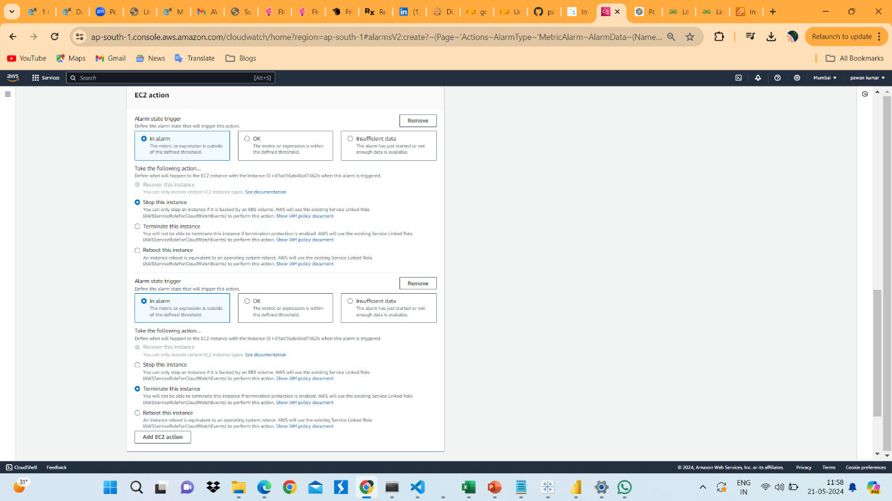

20. In Name and Describtion bar type Alert name as Email Alert CPU Utilization. In Edit Bar Type message which the notification send to Email. Then Click on Next.

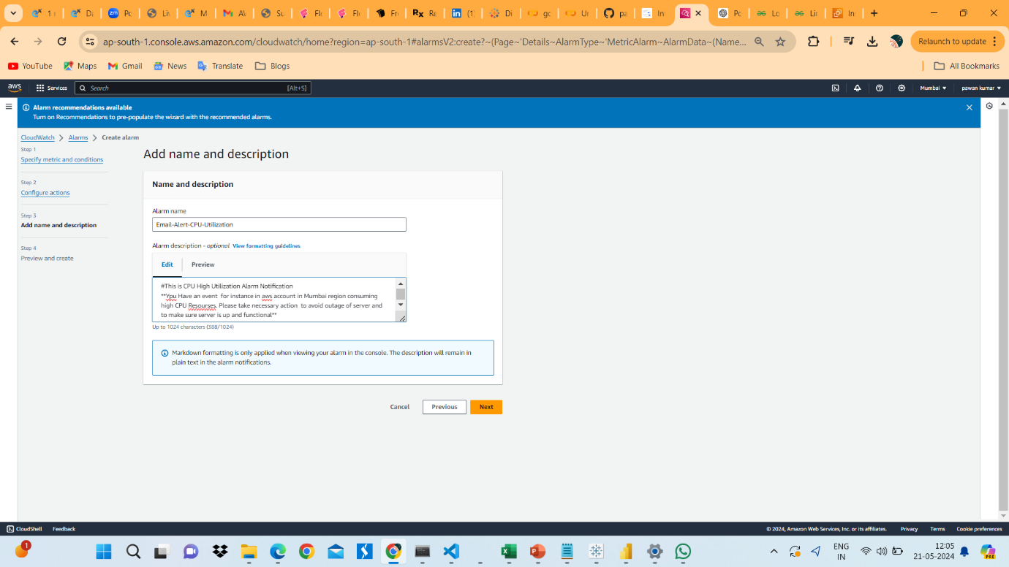

21. Next Click on Create Alarm.

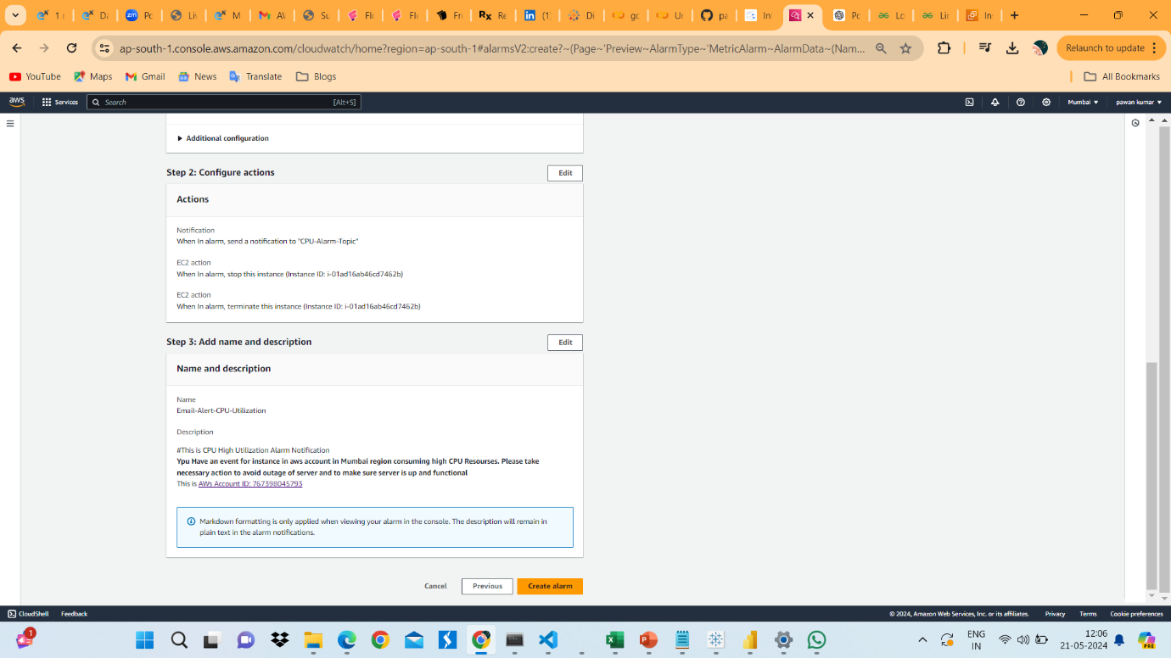

22. Launch an AWS Server EC2 Instance.

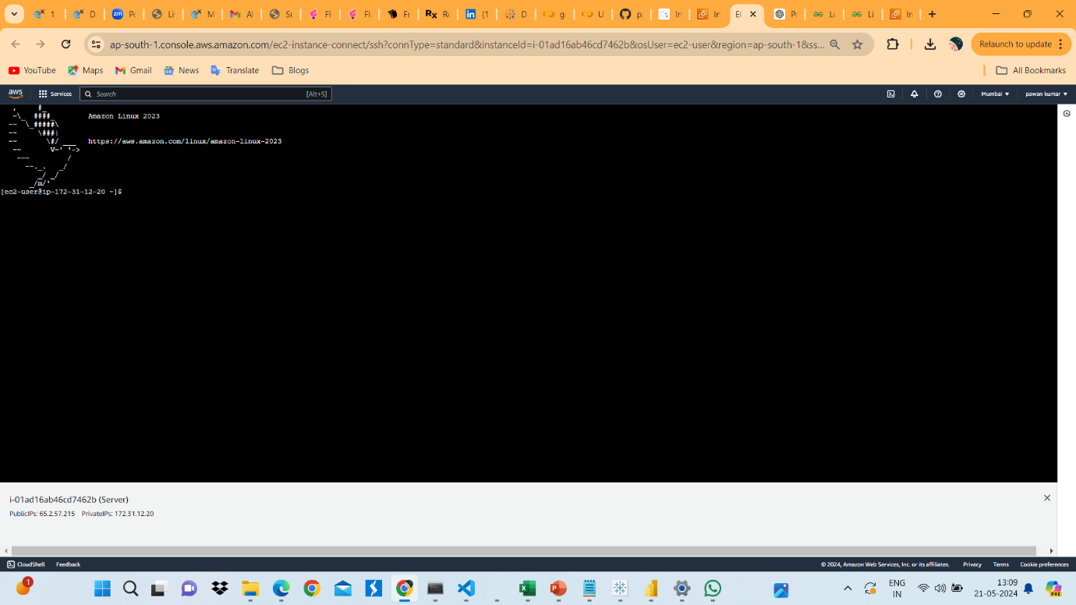

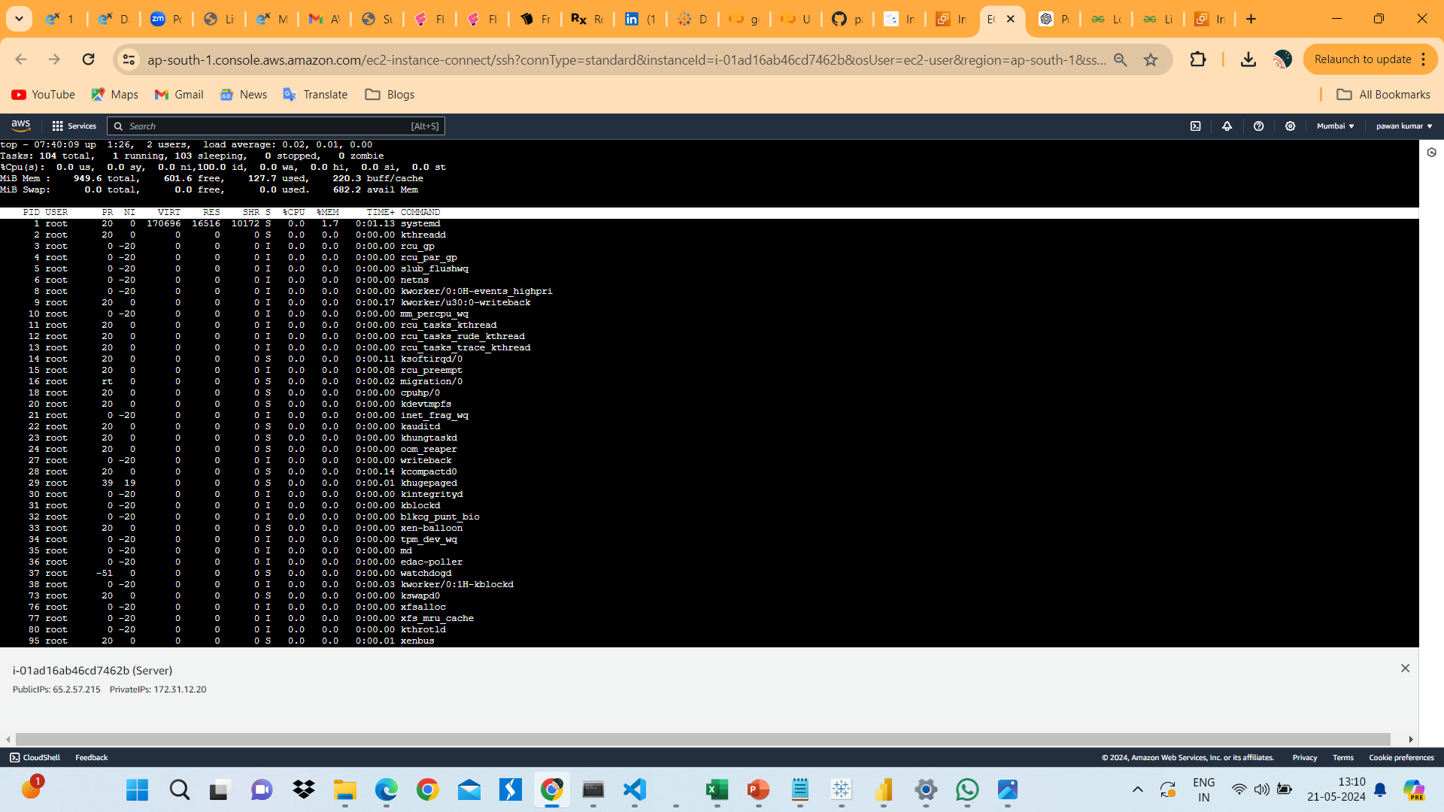

23. Check CPU Utilizatioin Percentage.

24. Instal some application which will reach 5 % of CPU Utilization.

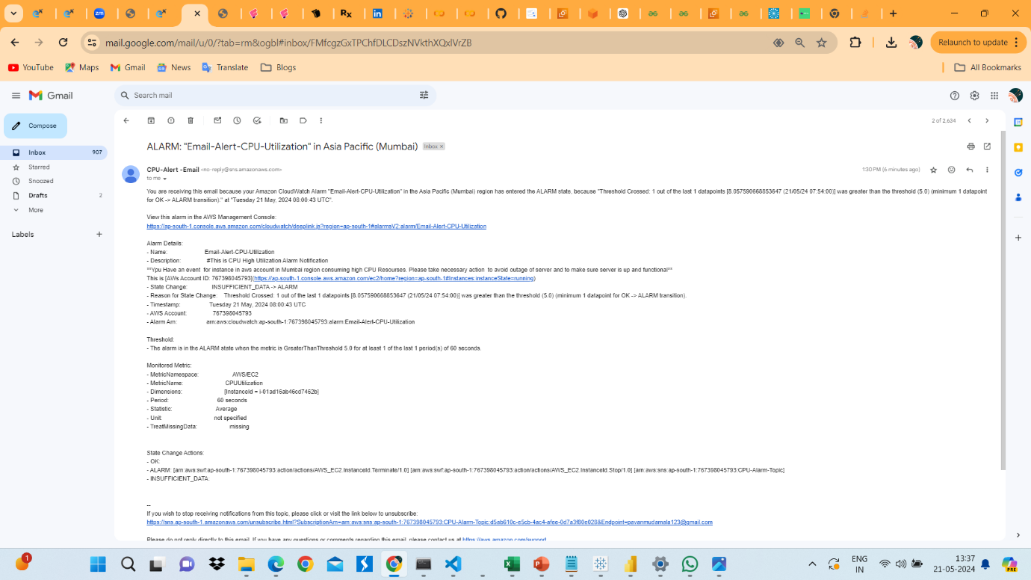

25. In Above image shows that after reaching the 5% of CPU Utilization Notification was send a Email.

26. And Also Ec2 Server Instance Stop and Terminated. You can see The below Image.

